Azure Cloud Learning Summary Report (3MTT Task)

1. Introduction
This report summarizes the activities completed during the Azure cloud fundamentals lab tasks. The exercise involved creating and managing resources in Microsoft Azure, exploring governance, deploying services, and configuring cost management tools.

2. Azure Region Selection
For this project, I selected South Africa North (Johannesburg) as the primary Azure region.
This region was chosen because it is the closest available Azure data center location to my geographic location (Lagos, Nigeria). Selecting a nearby region helps to reduce network latency, improve performance, and ensure more efficient communication between deployed cloud resources and users.
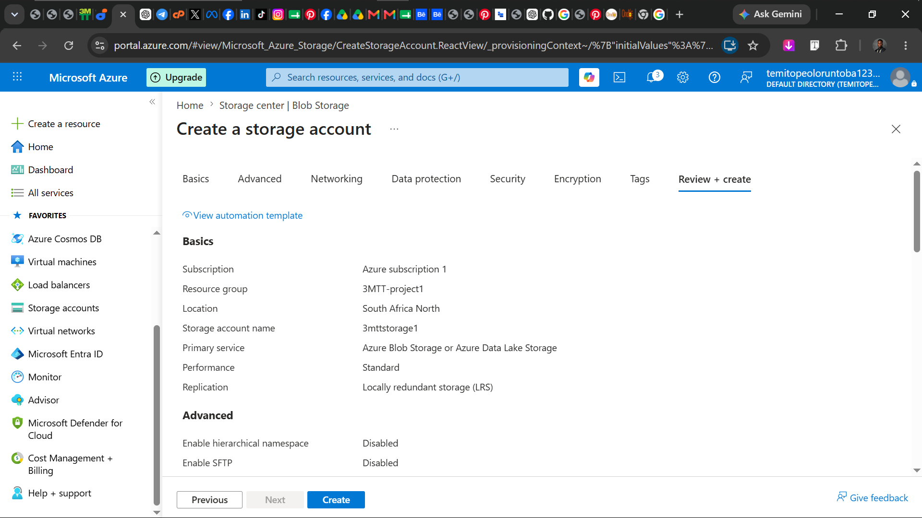

3. Resource Deployment
A basic Storage Account (StorageV2) was deployed successfully within the Azure portal. The resource was created inside the resource group 3MTT-project1.
The deployment process demonstrated how Azure validates configurations before provisioning resources and how services are organized within a logical structure known as a Resource Group.
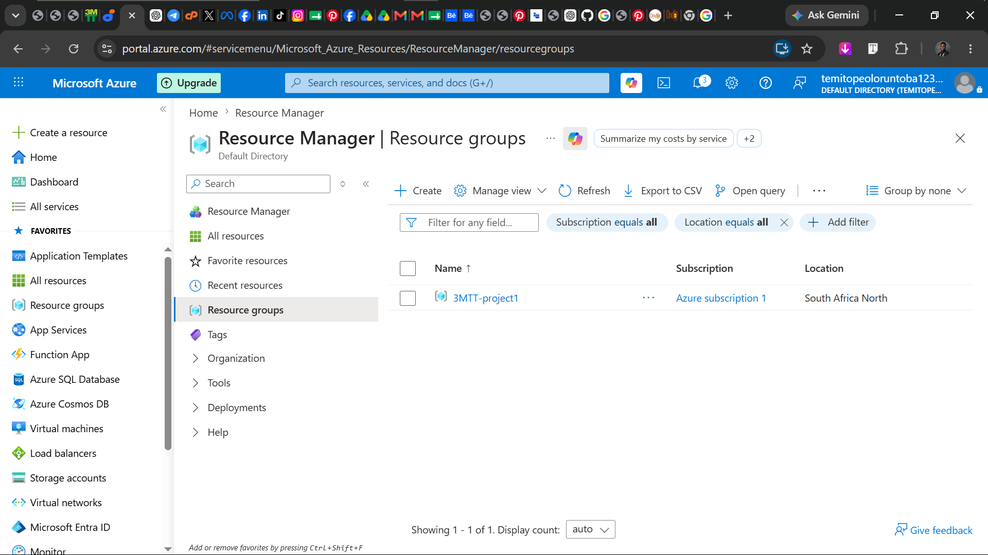

4. Shared Responsibility Model
The Shared Responsibility Model defines how security responsibilities are divided between Microsoft Azure (the cloud provider) and the customer.
- Microsoft Azure Responsibilities:
  - Physical security of data centers
  - Network infrastructure protection
  - Hardware maintenance
  - Platform availability and uptime
- Customer Responsibilities:
  - Managing user access and identity control
  - Configuring secure access to resources
  - Protecting data stored in Azure services
  - Monitoring and managing resource usage and configurations
In this project, I was responsible for configuring the resource group, deploying the storage account, and setting up cost monitoring, while Microsoft ensured the underlying infrastructure was secure and available.
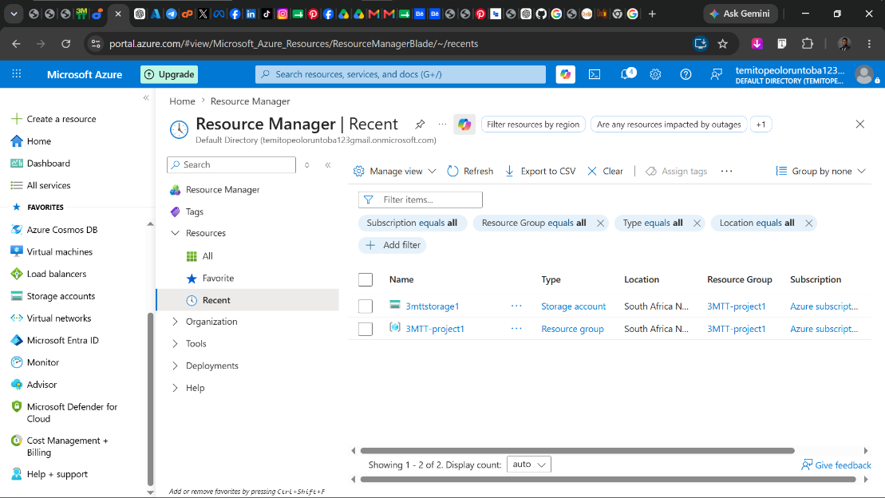

5. Cost Management
The Cost Management + Billing section was explored to understand how Azure tracks resource usage. A budget was created with alert thresholds to monitor spending and ensure that usage remains within Free Tier limits.
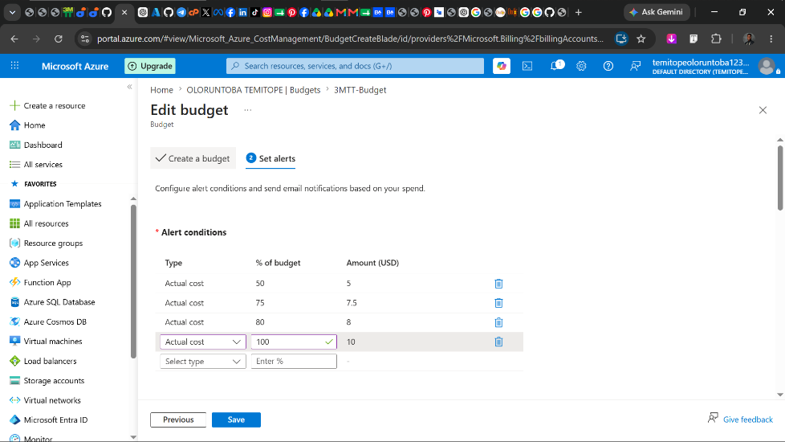

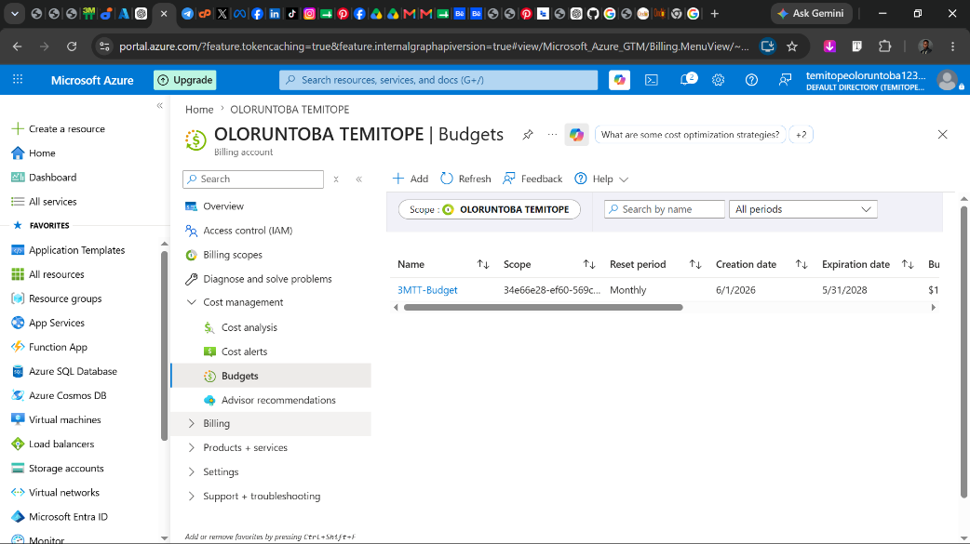

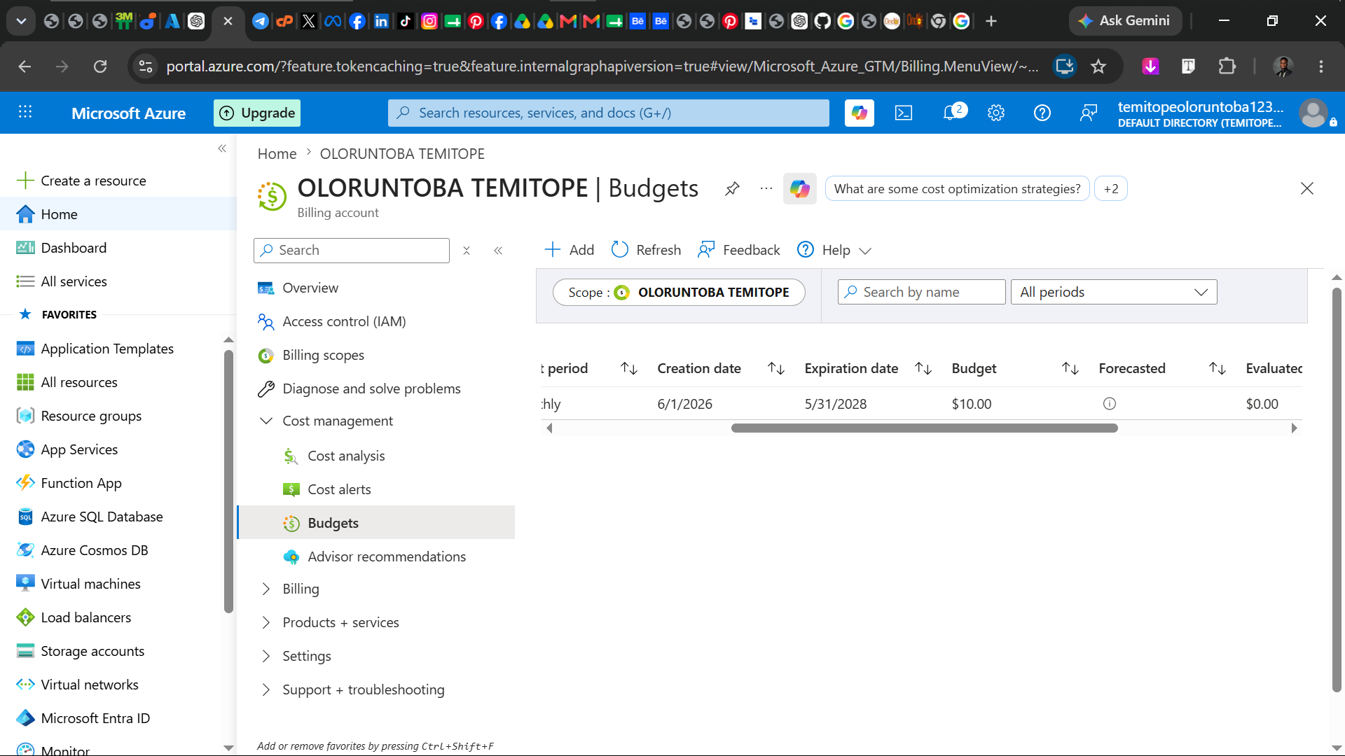

6. Conclusion
This exercise provided practical exposure to core Azure concepts, including resource deployment, governance, region selection, identity awareness, and cost management. It improved my understanding of cloud computing fundamentals and Azure service operations.

